**Machine Problem 1**

*Proof of testing*

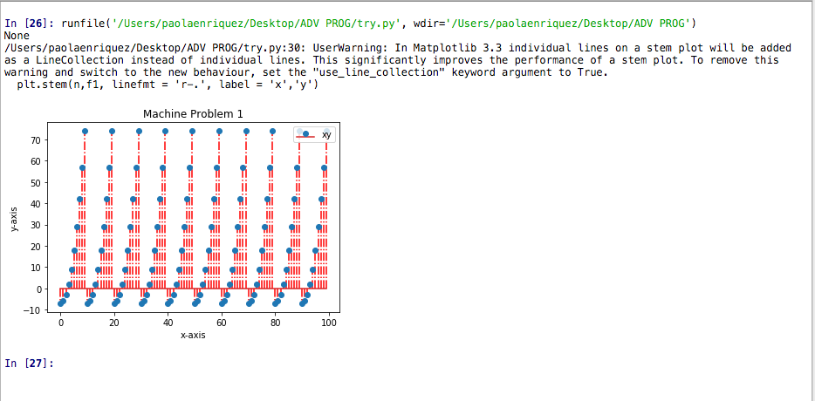

The graph on machine problem is not continuous and the plotting of the color blue has an equal increment ranging in 0 – 10 because the condition stated in the problem limits its value.

